**Skill and Chance: Revitalising Noughts and Crosses**

Zakaria Ahmed

**1.1 Game Premise**

In a group, we created a game similar to noughts and crosses but had added chanced based mechanics that would heavily modify gameplay. We did this by implementing a random event to occur that would change the board, for example a nought would be removed, or players would swap positions. This game would be appealing for adults as the chance mechanic is like gambling, the fact that there is chance and skill involved would make for exciting gameplay that would be very entertaining for older audiences.

**1.2 Materials**

The materials we had used played an important part to the development of the game. Here is the list of every material used and its purpose:

* Online Whiteboard (<https://awwapp.com/b/ubuyyuvatj5yd/>) was used as the gameboard to showcase our game
* Event picker (<https://wheeldecide.com>) this was a spin wheel where we had added events and was used as our chance mechanic
* Presentation Software – Screenshots and annotation of the game’s development was saved onto a presentation to be later used to show to the class and showcase

**1.3 Rules/Mechanics**

This game we had made was intended for 2 players

Rules:

* Coin Flip to decide the first player
* Every round is on a grid that's 3 squares by 3 squares
* Player 1 is X, player 2 is O. Players take turns putting their marks in empty squares
* The first player to get 3 of their marks in a row (horizontal, vertical or diagonal) is the winner
* When all squares are full, the game is a tie and the game is played again

The “chance” mechanic:

Every time a player has ended their turn, a wheel containing events is spun and is applied. The wheel can only be spun once per player’s turn

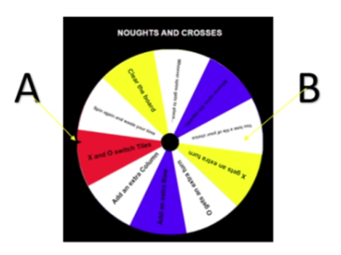

**Figure 1: Here is the wheel spinning mechanic. “A” is the counter that determines the event after a wheel spin and “B” is an example of an event.**

Here is the list we used of all the events that can occur in the wheel spin.

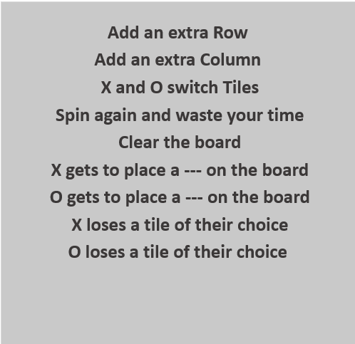

These are the possible vents that are applied to the game when a play had landed on one of these events during the time we had played

**1.4 How the game is played**

Internal game testing:

During the first play test, the gameplay was too quick and was not our intended effect, it was decided to do a wheel spin after the 2nd player’s turn. After this change, the game rounds had been longer which made the gameplay flow smoother.

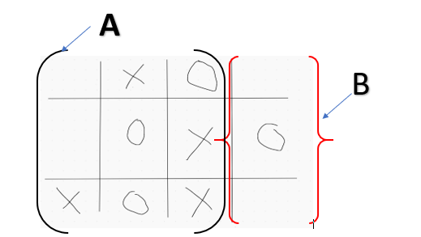

**Figure 2: Here is the first instance of our internal playtesting. “A” shows that the game was working as intended, “B” shows that our chance mechanic in effect as one of the events applied was added an extra row.**

External game testing:

After some external play testing, the other team had found out that the rules, X gets an extra turn and 0 gets an extra turn, were too unbalanced. The conclusion was to remove the rules as we had agreed that that particular random event was not ideal in a noughts and crosses game.

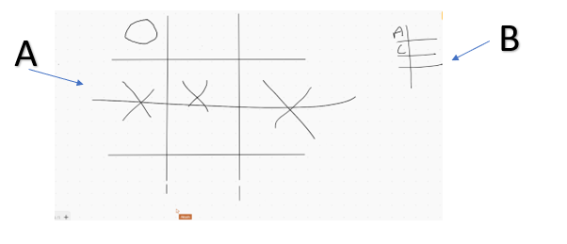

**Figure 3: Here is an instance of an external game played. “A” shows a game being played on the online whiteboard whilst they are keeping track of their score over at “B”**

**1.5 Teamwork/Reflection**

we have solved a problem together by decomposing our gameplay into simple tasks, played the game with ourselves and others, reviewed our opinions on it, fixed our concerns with the game. By doing this, we all concluded to remove some events in our random event picker as by keeping certain events it didn’t create the fun game we had imagined. Furthermore, we reflected on this considered this a good learning experience as we gathered opinions and concluded to fix flaws of our game which then created a better playing experience.

Team- Zakaria Ahmed, Joshua Baker, Jessica Evans, Hou Yap